Menu Choice A (£40 pp)

Starters

Homemade soup of the day
Chicken Liver and red-currant parfait with Ludlow Ale chutney
Salmon and cheddar fish cake with lemon mayo and a dill salad
Whipped Goats cheese, candied walnuts, roast beetroot, watercress and radish

Mains

Butter basted chicken supreme, potato galette, baby vegetables, butternut puree and a thyme jus
Slow roasted pork belly glazed with blossom honey served with sage mash, roasted baby apples, fresh greens and a cider jus
Fillet of Salmon with a basil and parmesan crust, saffron fondant potato and a petit ratatouille finished with a vermouth velouté
Butternut Squash risotto with goats’ cheese and sage (v)

Desserts

White chocolate and raspberry crème brûlée with blueberry shortbread
Salted caramel brownie with a warm chocolate shot and clotted cream ice cream
Baileys and mint cheesecake with a praline ice cream

Menu Choice B (£45pp)

Starters
Homemade soup of the day
Lemon chicken and basil terrine with heritage tomato salsa
Garlic, chilli and coriander king prawns with coconut infuse rice
Chargrilled Mediterranean vegetable rocket pesto and pecorino tart with a lemon and oregano dressing

Mains

Chargrilled lemon chicken with a sweet potato rösti, roasted baby vegetables and a basil cream
Gressingham duck breast with potato fondant, slow braided red cabbage and a red currant jus
Seared sea bass fillet accompanied by a saffron and crab potato cake, green beans, samphire and sauce vierge
Stir fried vegetable medley with wild garlic, chilli and ginger with herby rice and basil oil

Desserts
Banoffee crème brûlée topped with chantilly cream
Apple and rhubarb crumble with vanilla bean custard
Caramel and Biscoff cheesecake with raspberry puree and clotted cream ice cream

Menu Choice C (£55pp)

Starters

Homemade soup of the day
Crispy duck leg, watermelon and pomegranate salad with raspberry dressing
Pan seared scallops, fennel and lemon puree, chorizo salsa and dill infused oil
Saffron and wild mushroom arancini with truffle oil

Mains

Breast of chicken wrapped in Parma ham stuffed with a chorizo and tarragon mousseline served with dauphinoise potato, rainbow carrots and a madeira sauce
Confit leg of lamb with colcannon mash, buttered kale, chantaney carrots and a thyme jus
Fillet of monkfish roasted with Thai spices on a bed of coconut ad lime lentils served with sauteed pak choi, tempura prawns and a lightly spiced mango purée
Herb Crusted aubergine on a bed of Mediterranean cous cous with a sweet pepper concasse served with spinach, chickpea, lemon and cumin

Desserts

Dark chocolate and honeycomb cheesecake with zesty orange Chantilly and honeycomb ice cream
Sticky date pudding with boozy toffee sauce and a whisky ice cream
Lemon glazed tart with strawberry meringue and a peanut butter ice cream

Cold Buffet (£30pp)

Chicken Liver Parfait
Lemon and pepper prawns
Santa Fe Salad (peppers, corn, mixed beans, coriander and lime)
Naked Asian slaw
Greek rice salad
Bruschetta pasta salad
Charcuterie platter (cured meats, olives, chutney, pickles)
Local cheese selection (Worcestershire hop, Worcester gold, Worcester fig and honey, Shropshire blue grapes, celery)
Selection of warm breads
Selection of dips and sauces

Hot Buffet (£35pp)

Honey and maple glazed shoulder of pork with apple and rhubarb jus
Baked fillet of salmon with roasted fennel, lemon and parsley butter
Lebanese chicken with olives and artichokes
Creamy garlic potato dauphinoise
Apple, carrot and cabbage slaw
Baked new potatoes with salt and thyme
Roasted vegetable panache
Selection of warm breads

BBQ Buffet (£30pp)

Jerk chicken with chargrilled pineapple
Teriyaki glazed Tuna steak
Homemade Salwey burger
Sticky sweet chilli roast duck
Chargrilled corn on the cob
Santa Fe salad (peppers, corn, mixed beans, coriander and lime)
Naked Asian slaw
Sticky rice and peas
Potato fries

Hog Roast (£25 pp) + £100 hire fee

Minimum 30 people

Free range hog roast
Homemade apple sauce
Homemade stuffing
Brioche buns
Apple, carrot and cabbage slaw
Roasted potatoes
Selection of sauces
Pork jus

Light buffet

Suitable for meetings and wakes

£15 pp

Selection of freshly made sandwiches
Small selection of pastries
Fresh tea and coffee

£20 pp

Selection of freshly made sandwiches
Small selection of pastries
Selection of sweet treats
Potato fries or chunky chips
Fresh tea and coffee

Afternoon Tea (£20pp)

Minimum order of 6 per booking

A selection of freshly finger sandwiches (smoked salmon and cream cheese, coronation chicken, tuna and cucumber, ham and cheese)
Freshly baked scones and clotted cream and jam
A selection of miniature sweet treats
Freshly baked sausage rolls
Freshly baked quiche
Served with your choice of breakfast tea or freshly brewed filter coffee

Add a glass of fizz for £6 per head

Vegetarian/Vegan Options

Can be substituted on previous menus

Plant based ‘Beyond’ burger (BBQ)
Roasted vegetable coconut curry
Butternut squash, sage and cashew loaf
Green bean, sultana and parsley salad
Roasted sweet potato, pine nut and kale
Puy lentil and wild mushroom bolognaise
Mac and cheese with herby crust
Smoked wild mushroom stroganoff
Roasted chickpea, red onion, cumin, mint and feta (vegan option available)
Cous cous salad with sun blushed tomato, roasted butternut squash, peppers, fresh basil and feta cheese (vegan option available)

Canapes (£10 pp / 3ea.)

Smoked salmon, crème fraiche and dill blinis
Ham hock and sweet onion vol au vents
Bite size brioche burgers
Mini yorkshire puddings with Herefordshire beef and horseradish
Smoked mackerel pâté crostini (V)
Tomato, garlic and basil bruschetta (V)
Mini blue cheese rarebits with sweet chutney (V)
Roasted beetroot and courgette ciabatta bites (V)
Lemon and coriander hummus crostini

Desserts

Mini key lime pie
Mini lemon and strawberry meringue tart
Mini banoffee pie
Dark chocolate and honeycomb cheesecake
Salted caramel brownie
White chocolate and raspberry cheesecake
Caramel and Biscoff cheesecake
Cream filled profiteroles
Freshly baked churros

Why not treat yourselves on your special day to a special cheesecake, price on request

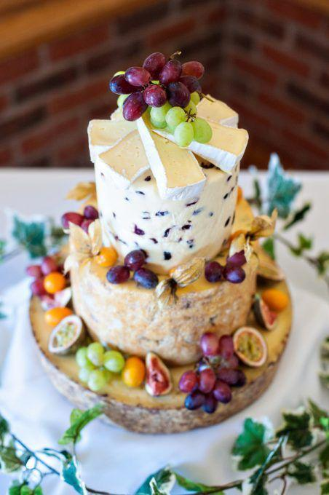
Cheese “cake” with biscuits, grapes, chutney

